Big Mountain Resort market searching and ticket change report

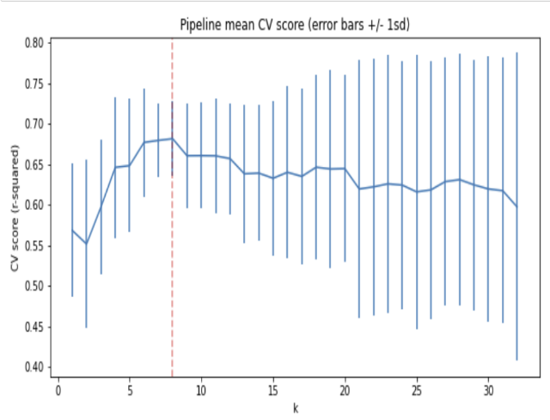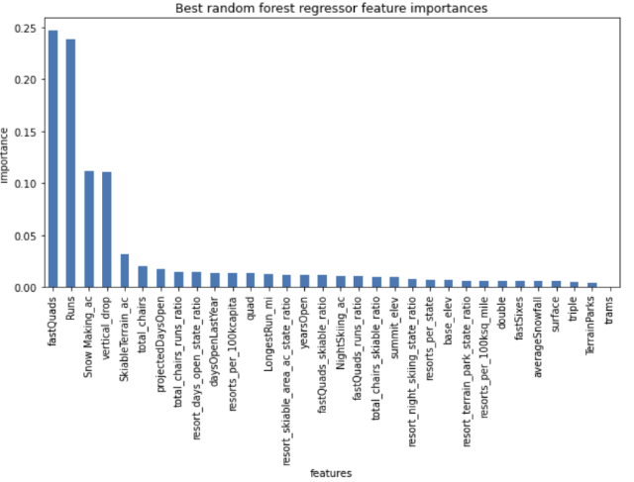The ski resort Big Mountain Resort in Montana faced high operating costs after installing the additional chair lift. Hence, company decide to improve ticket price to keep balance between operating cost and revenue. The project designs several training models to figure that company can increase ticket price in what extant, and how can company change operation plan. Passing cross-validation, pipeline mean cv score plot (*Figure.1*) indicates that the best value k for the ticket training model is 8. This means choose 8 features from the ski data as training feature is the best way. The linear model coefficients shows the most relative features are vertical drop (10.76), Snow Making ac (6.29), total chairs(5.79), fastQuads(5.74), Runs(5.37), Longest Run (0.18).On the other hand, trams and SkiableTerrain ac's coefficients is negative, which means increase the amount of trams and skiable area would cause worse situation to the resort.

*Figure.1* pipeline mean cv score plot  *Figure.2* random forest's feature importance

In the best random forest's feature importance bar chart (*Figure.2*), the result proves the correct of linear model coefficients. The features with the top 4 importance are fastQuads, Runs, Snow Making ac, vertical drop, so they will the feature most relevant to ticket price. One of the negative coefficient trams has the lowest importance, but SkiableTerrain ac has the fifth importance.

The ticker of Big Mountain Resort drawn from the model is $93.93, but the actual price is $81.00. Although in the Montana state, Big Mountain's Resort adult weekend ticket price

is the highest, but compare to other resort at all, it still has opportunity for improvement. Big Mountain Resort's vertical drop, snow making area, total number of chairs, runs, longest run and Skiable terrain area are at a higher level in the same category of market. I think these

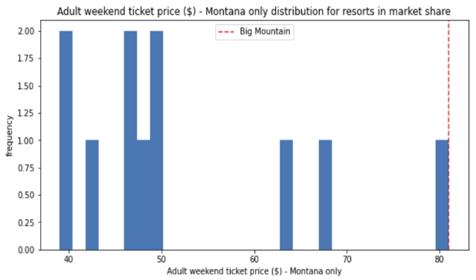infrastructures can support the increase in ticket.

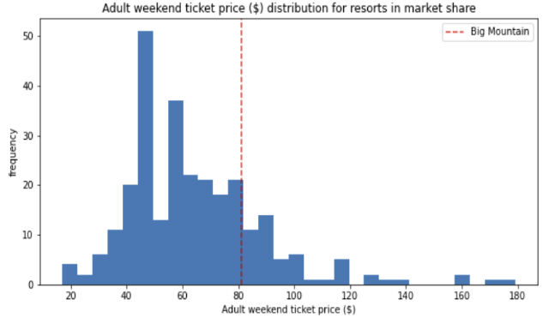

Ticket price in

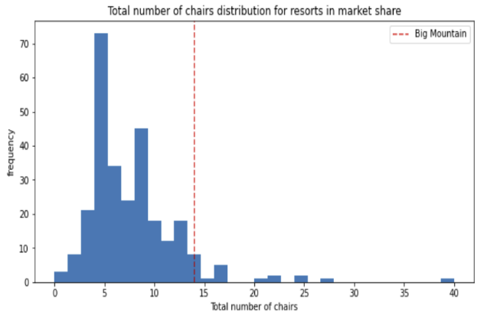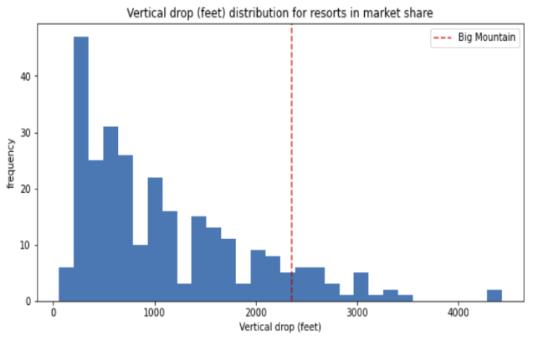

Vertical drop Total number of chairs

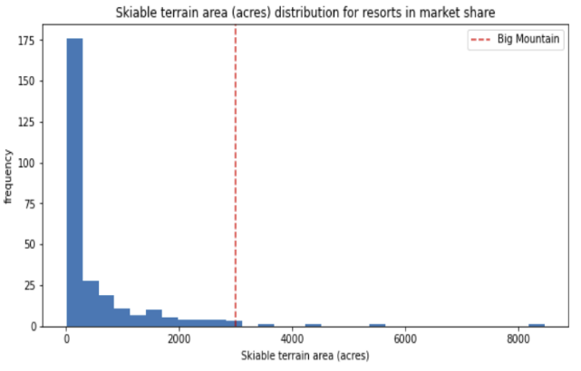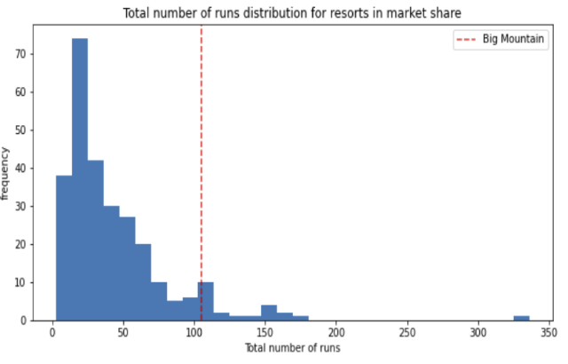

Total number of runs Skiable terrain area

About the run scenario, With only one run reduced, the ticket price has not changed. In the case of reducing more than four runs, the ticket price has been greatly reduced. With only one run reduced, the ticket price has not changed. Only when four runs were reduced or more, the ticket price dropped significantly. Conversely, if we increase the amount of the run, the height of vertical drop and the number of chairs, the ticket price will rise ($2.07) and get $3622500 per year. It is meaningless to continue to increase the snow making machine on this basis. Regarding which training model to choose, the r-square value of linear regression model is 0.632, and the random forest model r-square score is close to 0.71. Therefore, it is better to choose a random forest model.

So far, we have obtained the features (vertical drop, fastQuards, runs and snow making area) that are most relevant to the ticket price, as well as the features (chair, runs) that may help increase the ticket price. At the same time, we also obtained a random forest training model with a value of 0.71. These values will help us analyze the current situation of the resort, but they are not enough to get a better plan for the future. First of all, we still lack some key data. For example, the number of tourists last year. Because only the values of chairs and runs are not enough to get the operating costs of chairs and runs and the revenue obtained from them. We need the number of tourists to calculate. When the number of tourists reaches the level, the new ticket price of this plan can equalize the operating cost and get more revenue. On the contrary, if in order to reduce operating costs, how many runs should be reduced is the most appropriate.

The price of the existing ticket price is $81, and the ideal ticket price calculated by the model is $93.93. We can't just rely on this value to determine future ticket price. We also need more market comparisons, such as horizontal comparisons with other states. From the result of average ticket price by state, weekend ticket price in most states are higher than usual, while in Montana it is almost the same. What is the reason for this? Whether our future plans can make weekend ticket price higher than usual, and how other states formulate the difference between weekend and weekday ticket price. I think it can be used as a market reference.